Report - Assignments 1

# General Info

Team Members:

1. Guy Shitrit (204711576) – shitritg@post.bgu.ac.il
2. Ofir Dvir (308293950) – ofirdvi@post.bgu.ac.il
3. Assaf Nahum (305622409) – assafna@post.bgu.ac.il
4. Noam Moscovich (308353341) – noammosc@post.bgu.ac.il

EC Tool:

1. Python DEAP - <https://deap.readthedocs.io/en/master/api/tools.html>

# eVOLUTIONARY ALGORITHM PARAMENERS - SUMMARY

In these assignment, we run five different experiments configurations as follow:

Experiment 1:

|  |  |
| --- | --- |
| Representation | Array |
| Recombination | single point crossover |
| Recombination probability | 70% |
| Mutation | one point mutation |
| Mutation probability | 0.1% |
| Parent selection | roulette-wheel sampling |
| Survival selection |  |
| Population size | 100 |
| Initialization | random |
| Termination conditions | Creation of 100 generation |

Experiment 2:

|  |  |
| --- | --- |
| Representation | Permutation |
| Recombination | Partially Matched |
| Recombination probability | 40% |
| Mutation | Two values random swapping |
| Mutation probability | 0.1% |
| Parent selection | roulette-wheel sampling |
| Survival selection |  |
| Population size | 100 |
| Initialization | random |
| Termination conditions | Creation of 100 generation |

Experiment 3:

|  |  |
| --- | --- |
| Representation | Permutation |
| Recombination | Partially Matched |
| Recombination probability | 10% |
| Mutation | Two values random swapping |
| Mutation probability | 0.1% |
| Parent selection | roulette-wheel sampling |
| Survival selection |  |
| Population size | 100 |
| Initialization | random |
| Termination conditions | Creation of 100 generation |

Experiment 4:

|  |  |
| --- | --- |
| Representation | Permutation |
| Recombination | Partially Matched |
| Recombination probability | 70% |
| Mutation | Two values random swapping |
| Mutation probability | 1% |
| Parent selection | roulette-wheel sampling |
| Survival selection |  |
| Population size | 100 |
| Initialization | random |
| Termination conditions | Creation of 100 generation |

Experiment 3:

|  |  |
| --- | --- |
| Representation | Permutation |
| Recombination | Partially Matched |
| Recombination probability | 70% |
| Mutation | Two values random swapping |
| Mutation probability | 10% |
| Parent selection | roulette-wheel sampling |
| Survival selection |  |
| Population size | 100 |
| Initialization | random |
| Termination conditions | Creation of 100 generation |

# pROCESS OF WORK

We chose to implement our code with a package called DEAP in Python, which contains most of the functions we were required to use.

However, In order to fulfill the assignment requirements, we added two functions ourselves:

1. **evaluateFunc**: calculates the fitness score for each individual.

The fitness score represents the amount of conflicts that each individual has by the following formula: ${Score}_{fitness}= \frac{1}{\#conflicts+1}$

Therefore, the best individual is represented by the maximum score (min fitness).

Hence, the Haier the score means the individual represents a possibility that is closer to solving the 8 Queens problem.

We chose maximum fitness because the selection function we were required to use in the assignment cannot work with a minimum fitness. And we added one in the denominator to avoid the zero-division.

Conflicts calculation - In the assignment we were asked to represent individuals in two different methods: array or permutation. Due to the differences that exist between the two (in array representation there can be repetitions), the number of conflicts calculated differently for each representation.

When for permutations, conflicts were calculated in diagonals only, whereas in arrays, conflicts were calculated in both diagonals and rows.

1. **createMutate:**

Similar to the conflicts calculation, the mutation generation method was also different between the two types of representations. When for arrays we used ‘one point mutate’ method as requested in the assignment and for permutations we used the ‘two point swapping’ as we learned in the lecture.

# RESULTS

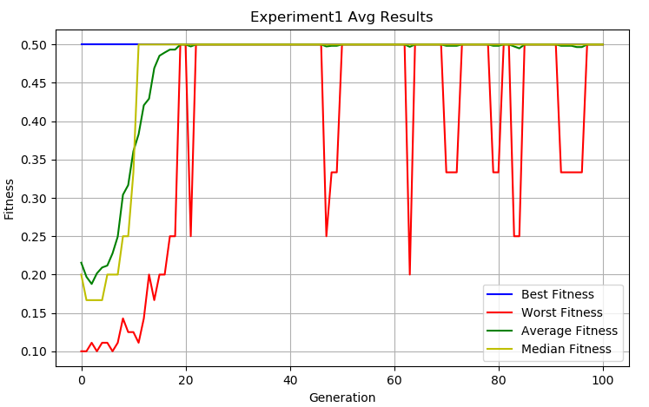 Experiment 1:

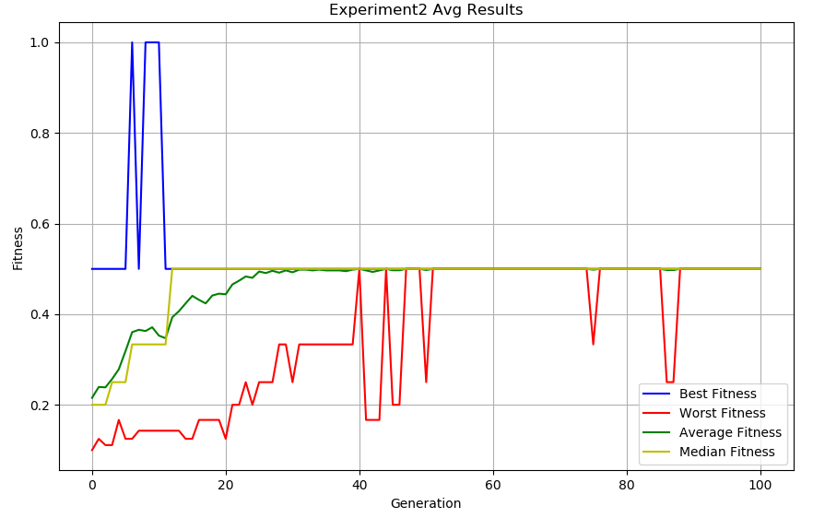Experiment 2:

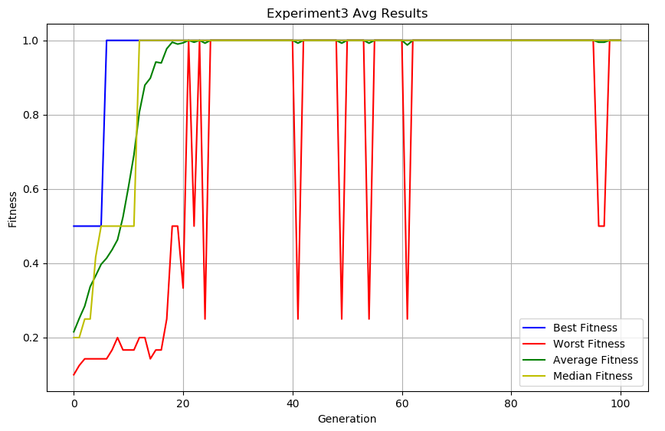Experiment 3:

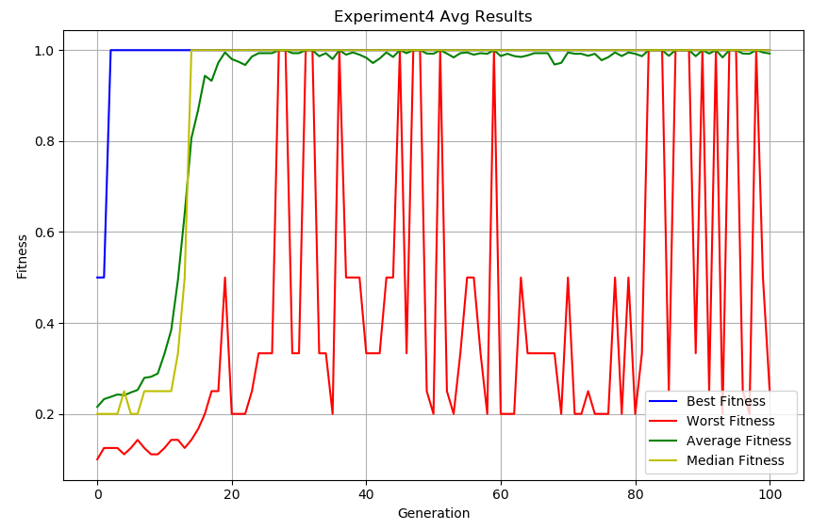Experiment 4:

Experiment 5:

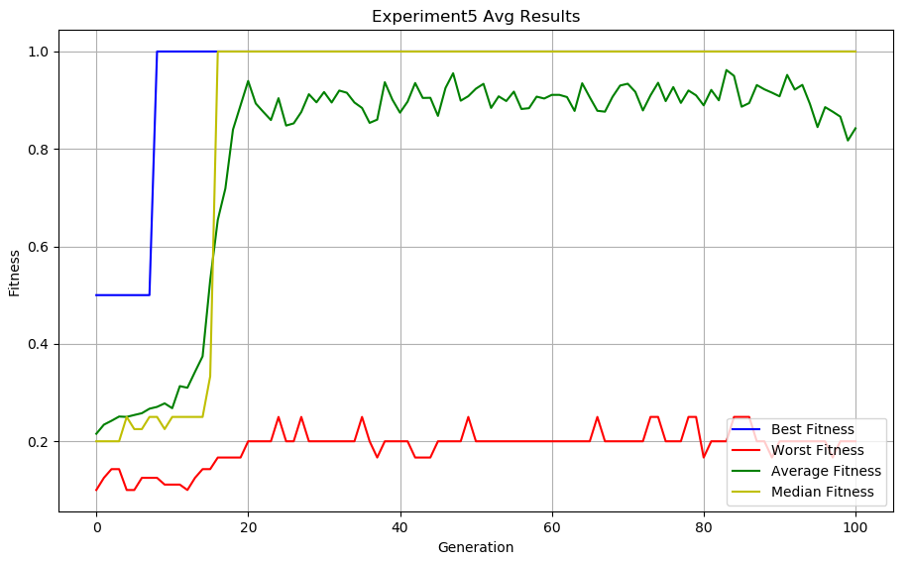

# CONCLUSIONS

1. The solution that was found is not the optimal solution. This is because the algorithm continued to execute instead of stopping when it found the optimal solution. In this case, it was necessary to add to the termination condition that if an optimal solution is found (i.e., no conflicts between the queens) the algorithm execution should be terminate.
2. Using permutation is more suits to the queen problem than using array because it reduces the problem. By using permutation, we need to find conflicts on diagonals only because we do not create invalid individuals in the first place (which has repetitions, i.e. the placement of two queens in the same row) and therefore it optimizes the algorithm. We concluded this when we examined the difference between the results of the first and second experiments. When we used permutation our results were better than using permutation that didn’t led to the optimal solution at all.
3. Low probability of mutation leads to better results. We concluded this when we examined the difference between the results of the fourth and fifth experiments. When we increased the probability of mutation our results became worst.
4. A high probability of crossover leads to better results. We concluded this when we examined the difference between the results of the third and fourth experiments. When we increased the crossover probability in the third experiment we got the best results even when we raised the probability of mutation

# FUTURE WORK

1. Perform the experiment with a termination condition that relates to the optimal solution - that is, let the algorithm execute up to 100 generations **or** until the optimal solution is found
2. Performing the experiment with different selection function to see if we can reach better results

# Appendices

**The average results of the experiments per generation:**

Experiment 1:

|  |  |  |  |  |
| --- | --- | --- | --- | --- |
| Generation | Best Fitness | Worst Fitness | Average Fitness | Median Fitness |
| 0 | 0.50 | 0.10 | 0.22 | 0.20 |
| 1 | 0.50 | 0.10 | 0.20 | 0.17 |
| 2 | 0.50 | 0.11 | 0.19 | 0.17 |
| 3 | 0.50 | 0.10 | 0.20 | 0.17 |
| 4 | 0.50 | 0.11 | 0.21 | 0.17 |
| 5 | 0.50 | 0.11 | 0.21 | 0.20 |
| 6 | 0.50 | 0.10 | 0.23 | 0.20 |
| 7 | 0.50 | 0.11 | 0.25 | 0.20 |
| 8 | 0.50 | 0.14 | 0.30 | 0.25 |
| 9 | 0.50 | 0.13 | 0.32 | 0.25 |
| 10 | 0.50 | 0.13 | 0.36 | 0.33 |
| 11 | 0.50 | 0.11 | 0.38 | 0.50 |
| 12 | 0.50 | 0.14 | 0.42 | 0.50 |
| 13 | 0.50 | 0.20 | 0.43 | 0.50 |
| 14 | 0.50 | 0.17 | 0.47 | 0.50 |
| 15 | 0.50 | 0.20 | 0.49 | 0.50 |
| 16 | 0.50 | 0.20 | 0.49 | 0.50 |
| 17 | 0.50 | 0.25 | 0.49 | 0.50 |
| 18 | 0.50 | 0.25 | 0.49 | 0.50 |
| 19 | 0.50 | 0.50 | 0.50 | 0.50 |
| 20 | 0.50 | 0.50 | 0.50 | 0.50 |
| 21 | 0.50 | 0.25 | 0.50 | 0.50 |
| 22 | 0.50 | 0.50 | 0.50 | 0.50 |
| 23 | 0.50 | 0.50 | 0.50 | 0.50 |
| 24 | 0.50 | 0.50 | 0.50 | 0.50 |
| 25 | 0.50 | 0.50 | 0.50 | 0.50 |
| 26 | 0.50 | 0.50 | 0.50 | 0.50 |
| 27 | 0.50 | 0.50 | 0.50 | 0.50 |
| 28 | 0.50 | 0.50 | 0.50 | 0.50 |
| 29 | 0.50 | 0.50 | 0.50 | 0.50 |
| 30 | 0.50 | 0.50 | 0.50 | 0.50 |
| 31 | 0.50 | 0.50 | 0.50 | 0.50 |
| 32 | 0.50 | 0.50 | 0.50 | 0.50 |
| 33 | 0.50 | 0.50 | 0.50 | 0.50 |
| 34 | 0.50 | 0.50 | 0.50 | 0.50 |
| 35 | 0.50 | 0.50 | 0.50 | 0.50 |
| 36 | 0.50 | 0.50 | 0.50 | 0.50 |
| 37 | 0.50 | 0.50 | 0.50 | 0.50 |
| 38 | 0.50 | 0.50 | 0.50 | 0.50 |
| 39 | 0.50 | 0.50 | 0.50 | 0.50 |
| 40 | 0.50 | 0.50 | 0.50 | 0.50 |
| 41 | 0.50 | 0.50 | 0.50 | 0.50 |
| 42 | 0.50 | 0.50 | 0.50 | 0.50 |
| 43 | 0.50 | 0.50 | 0.50 | 0.50 |
| 44 | 0.50 | 0.50 | 0.50 | 0.50 |
| 45 | 0.50 | 0.50 | 0.50 | 0.50 |
| 46 | 0.50 | 0.50 | 0.50 | 0.50 |
| 47 | 0.50 | 0.25 | 0.50 | 0.50 |
| 48 | 0.50 | 0.33 | 0.50 | 0.50 |
| 49 | 0.50 | 0.33 | 0.50 | 0.50 |
| 50 | 0.50 | 0.50 | 0.50 | 0.50 |
| 51 | 0.50 | 0.50 | 0.50 | 0.50 |
| 52 | 0.50 | 0.50 | 0.50 | 0.50 |
| 53 | 0.50 | 0.50 | 0.50 | 0.50 |
| 54 | 0.50 | 0.50 | 0.50 | 0.50 |
| 55 | 0.50 | 0.50 | 0.50 | 0.50 |
| 56 | 0.50 | 0.50 | 0.50 | 0.50 |
| 57 | 0.50 | 0.50 | 0.50 | 0.50 |
| 58 | 0.50 | 0.50 | 0.50 | 0.50 |
| 59 | 0.50 | 0.50 | 0.50 | 0.50 |
| 60 | 0.50 | 0.50 | 0.50 | 0.50 |
| 61 | 0.50 | 0.50 | 0.50 | 0.50 |
| 62 | 0.50 | 0.50 | 0.50 | 0.50 |
| 63 | 0.50 | 0.20 | 0.50 | 0.50 |
| 64 | 0.50 | 0.50 | 0.50 | 0.50 |
| 65 | 0.50 | 0.50 | 0.50 | 0.50 |
| 66 | 0.50 | 0.50 | 0.50 | 0.50 |
| 67 | 0.50 | 0.50 | 0.50 | 0.50 |
| 68 | 0.50 | 0.50 | 0.50 | 0.50 |
| 69 | 0.50 | 0.50 | 0.50 | 0.50 |
| 70 | 0.50 | 0.33 | 0.50 | 0.50 |
| 71 | 0.50 | 0.33 | 0.50 | 0.50 |
| 72 | 0.50 | 0.33 | 0.50 | 0.50 |
| 73 | 0.50 | 0.50 | 0.50 | 0.50 |
| 74 | 0.50 | 0.50 | 0.50 | 0.50 |
| 75 | 0.50 | 0.50 | 0.50 | 0.50 |
| 76 | 0.50 | 0.50 | 0.50 | 0.50 |
| 77 | 0.50 | 0.50 | 0.50 | 0.50 |
| 78 | 0.50 | 0.50 | 0.50 | 0.50 |
| 79 | 0.50 | 0.33 | 0.50 | 0.50 |
| 80 | 0.50 | 0.33 | 0.50 | 0.50 |
| 81 | 0.50 | 0.50 | 0.50 | 0.50 |
| 82 | 0.50 | 0.50 | 0.50 | 0.50 |
| 83 | 0.50 | 0.25 | 0.50 | 0.50 |
| 84 | 0.50 | 0.25 | 0.50 | 0.50 |
| 85 | 0.50 | 0.50 | 0.50 | 0.50 |
| 86 | 0.50 | 0.50 | 0.50 | 0.50 |
| 87 | 0.50 | 0.50 | 0.50 | 0.50 |
| 88 | 0.50 | 0.50 | 0.50 | 0.50 |
| 89 | 0.50 | 0.50 | 0.50 | 0.50 |
| 90 | 0.50 | 0.50 | 0.50 | 0.50 |
| 91 | 0.50 | 0.50 | 0.50 | 0.50 |
| 92 | 0.50 | 0.33 | 0.50 | 0.50 |
| 93 | 0.50 | 0.33 | 0.50 | 0.50 |
| 94 | 0.50 | 0.33 | 0.50 | 0.50 |
| 95 | 0.50 | 0.33 | 0.50 | 0.50 |
| 96 | 0.50 | 0.33 | 0.50 | 0.50 |
| 97 | 0.50 | 0.50 | 0.50 | 0.50 |
| 98 | 0.50 | 0.50 | 0.50 | 0.50 |
| 99 | 0.50 | 0.50 | 0.50 | 0.50 |
| 100 | 0.50 | 0.50 | 0.50 | 0.50 |

Experiment 2:

|  |  |  |  |  |
| --- | --- | --- | --- | --- |
| Generation | Best Fitness | Worst Fitness | Average Fitness | Median Fitness |
| 0 | 0.500 | 0.100 | 0.215 | 0.200 |
| 1 | 0.500 | 0.125 | 0.239 | 0.200 |
| 2 | 0.500 | 0.111 | 0.239 | 0.200 |
| 3 | 0.500 | 0.111 | 0.257 | 0.250 |
| 4 | 0.500 | 0.167 | 0.279 | 0.250 |
| 5 | 0.500 | 0.125 | 0.318 | 0.250 |
| 6 | 1.000 | 0.125 | 0.360 | 0.333 |
| 7 | 0.500 | 0.143 | 0.366 | 0.333 |
| 8 | 1.000 | 0.143 | 0.363 | 0.333 |
| 9 | 1.000 | 0.143 | 0.371 | 0.333 |
| 10 | 1.000 | 0.143 | 0.353 | 0.333 |
| 11 | 0.500 | 0.143 | 0.347 | 0.333 |
| 12 | 0.500 | 0.143 | 0.393 | 0.500 |
| 13 | 0.500 | 0.143 | 0.407 | 0.500 |
| 14 | 0.500 | 0.125 | 0.424 | 0.500 |
| 15 | 0.500 | 0.125 | 0.441 | 0.500 |
| 16 | 0.500 | 0.167 | 0.432 | 0.500 |
| 17 | 0.500 | 0.167 | 0.424 | 0.500 |
| 18 | 0.500 | 0.167 | 0.441 | 0.500 |
| 19 | 0.500 | 0.167 | 0.445 | 0.500 |
| 20 | 0.500 | 0.125 | 0.444 | 0.500 |
| 21 | 0.500 | 0.200 | 0.466 | 0.500 |
| 22 | 0.500 | 0.200 | 0.474 | 0.500 |
| 23 | 0.500 | 0.250 | 0.483 | 0.500 |
| 24 | 0.500 | 0.200 | 0.480 | 0.500 |
| 25 | 0.500 | 0.250 | 0.494 | 0.500 |
| 26 | 0.500 | 0.250 | 0.491 | 0.500 |
| 27 | 0.500 | 0.250 | 0.496 | 0.500 |
| 28 | 0.500 | 0.333 | 0.492 | 0.500 |
| 29 | 0.500 | 0.333 | 0.497 | 0.500 |
| 30 | 0.500 | 0.250 | 0.493 | 0.500 |
| 31 | 0.500 | 0.333 | 0.498 | 0.500 |
| 32 | 0.500 | 0.333 | 0.498 | 0.500 |
| 33 | 0.500 | 0.333 | 0.497 | 0.500 |
| 34 | 0.500 | 0.333 | 0.498 | 0.500 |
| 35 | 0.500 | 0.333 | 0.497 | 0.500 |
| 36 | 0.500 | 0.333 | 0.497 | 0.500 |
| 37 | 0.500 | 0.333 | 0.497 | 0.500 |
| 38 | 0.500 | 0.333 | 0.495 | 0.500 |
| 39 | 0.500 | 0.333 | 0.498 | 0.500 |
| 40 | 0.500 | 0.500 | 0.500 | 0.500 |
| 41 | 0.500 | 0.167 | 0.497 | 0.500 |
| 42 | 0.500 | 0.167 | 0.493 | 0.500 |
| 43 | 0.500 | 0.167 | 0.497 | 0.500 |
| 44 | 0.500 | 0.500 | 0.500 | 0.500 |
| 45 | 0.500 | 0.200 | 0.497 | 0.500 |
| 46 | 0.500 | 0.200 | 0.497 | 0.500 |
| 47 | 0.500 | 0.500 | 0.500 | 0.500 |
| 48 | 0.500 | 0.500 | 0.500 | 0.500 |
| 49 | 0.500 | 0.500 | 0.500 | 0.500 |
| 50 | 0.500 | 0.250 | 0.498 | 0.500 |
| 51 | 0.500 | 0.500 | 0.500 | 0.500 |
| 52 | 0.500 | 0.500 | 0.500 | 0.500 |
| 53 | 0.500 | 0.500 | 0.500 | 0.500 |
| 54 | 0.500 | 0.500 | 0.500 | 0.500 |
| 55 | 0.500 | 0.500 | 0.500 | 0.500 |
| 56 | 0.500 | 0.500 | 0.500 | 0.500 |
| 57 | 0.500 | 0.500 | 0.500 | 0.500 |
| 58 | 0.500 | 0.500 | 0.500 | 0.500 |
| 59 | 0.500 | 0.500 | 0.500 | 0.500 |
| 60 | 0.500 | 0.500 | 0.500 | 0.500 |
| 61 | 0.500 | 0.500 | 0.500 | 0.500 |
| 62 | 0.500 | 0.500 | 0.500 | 0.500 |
| 63 | 0.500 | 0.500 | 0.500 | 0.500 |
| 64 | 0.500 | 0.500 | 0.500 | 0.500 |
| 65 | 0.500 | 0.500 | 0.500 | 0.500 |
| 66 | 0.500 | 0.500 | 0.500 | 0.500 |
| 67 | 0.500 | 0.500 | 0.500 | 0.500 |
| 68 | 0.500 | 0.500 | 0.500 | 0.500 |
| 69 | 0.500 | 0.500 | 0.500 | 0.500 |
| 70 | 0.500 | 0.500 | 0.500 | 0.500 |
| 71 | 0.500 | 0.500 | 0.500 | 0.500 |
| 72 | 0.500 | 0.500 | 0.500 | 0.500 |
| 73 | 0.500 | 0.500 | 0.500 | 0.500 |
| 74 | 0.500 | 0.500 | 0.500 | 0.500 |
| 75 | 0.500 | 0.333 | 0.498 | 0.500 |
| 76 | 0.500 | 0.500 | 0.500 | 0.500 |
| 77 | 0.500 | 0.500 | 0.500 | 0.500 |
| 78 | 0.500 | 0.500 | 0.500 | 0.500 |
| 79 | 0.500 | 0.500 | 0.500 | 0.500 |
| 80 | 0.500 | 0.500 | 0.500 | 0.500 |
| 81 | 0.500 | 0.500 | 0.500 | 0.500 |
| 82 | 0.500 | 0.500 | 0.500 | 0.500 |
| 83 | 0.500 | 0.500 | 0.500 | 0.500 |
| 84 | 0.500 | 0.500 | 0.500 | 0.500 |
| 85 | 0.500 | 0.500 | 0.500 | 0.500 |
| 86 | 0.500 | 0.250 | 0.498 | 0.500 |
| 87 | 0.500 | 0.250 | 0.498 | 0.500 |
| 88 | 0.500 | 0.500 | 0.500 | 0.500 |
| 89 | 0.500 | 0.500 | 0.500 | 0.500 |
| 90 | 0.500 | 0.500 | 0.500 | 0.500 |
| 91 | 0.500 | 0.500 | 0.500 | 0.500 |
| 92 | 0.500 | 0.500 | 0.500 | 0.500 |
| 93 | 0.500 | 0.500 | 0.500 | 0.500 |
| 94 | 0.500 | 0.500 | 0.500 | 0.500 |
| 95 | 0.500 | 0.500 | 0.500 | 0.500 |
| 96 | 0.500 | 0.500 | 0.500 | 0.500 |
| 97 | 0.500 | 0.500 | 0.500 | 0.500 |
| 98 | 0.500 | 0.500 | 0.500 | 0.500 |
| 99 | 0.500 | 0.500 | 0.500 | 0.500 |
| 100 | 0.500 | 0.500 | 0.500 | 0.500 |

Experiment 3:

|  |  |  |  |  |
| --- | --- | --- | --- | --- |
| Generation | Best Fitness | Worst Fitness | Average Fitness | Median Fitness |
| 0 | 0.500 | 0.100 | 0.215 | 0.200 |
| 1 | 0.500 | 0.125 | 0.252 | 0.200 |
| 2 | 0.500 | 0.143 | 0.285 | 0.250 |
| 3 | 0.500 | 0.143 | 0.337 | 0.250 |
| 4 | 0.500 | 0.143 | 0.366 | 0.417 |
| 5 | 0.500 | 0.143 | 0.397 | 0.500 |
| 6 | 1.000 | 0.143 | 0.414 | 0.500 |
| 7 | 1.000 | 0.167 | 0.436 | 0.500 |
| 8 | 1.000 | 0.200 | 0.463 | 0.500 |
| 9 | 1.000 | 0.167 | 0.525 | 0.500 |
| 10 | 1.000 | 0.167 | 0.605 | 0.500 |
| 11 | 1.000 | 0.167 | 0.692 | 0.500 |
| 12 | 1.000 | 0.200 | 0.807 | 1.000 |
| 13 | 1.000 | 0.200 | 0.880 | 1.000 |
| 14 | 1.000 | 0.143 | 0.898 | 1.000 |
| 15 | 1.000 | 0.167 | 0.942 | 1.000 |
| 16 | 1.000 | 0.167 | 0.939 | 1.000 |
| 17 | 1.000 | 0.250 | 0.978 | 1.000 |
| 18 | 1.000 | 0.500 | 0.995 | 1.000 |
| 19 | 1.000 | 0.500 | 0.990 | 1.000 |
| 20 | 1.000 | 0.333 | 0.993 | 1.000 |
| 21 | 1.000 | 1.000 | 1.000 | 1.000 |
| 22 | 1.000 | 0.500 | 0.995 | 1.000 |
| 23 | 1.000 | 1.000 | 1.000 | 1.000 |
| 24 | 1.000 | 0.250 | 0.993 | 1.000 |
| 25 | 1.000 | 1.000 | 1.000 | 1.000 |
| 26 | 1.000 | 1.000 | 1.000 | 1.000 |
| 27 | 1.000 | 1.000 | 1.000 | 1.000 |
| 28 | 1.000 | 1.000 | 1.000 | 1.000 |
| 29 | 1.000 | 1.000 | 1.000 | 1.000 |
| 30 | 1.000 | 1.000 | 1.000 | 1.000 |
| 31 | 1.000 | 1.000 | 1.000 | 1.000 |
| 32 | 1.000 | 1.000 | 1.000 | 1.000 |
| 33 | 1.000 | 1.000 | 1.000 | 1.000 |
| 34 | 1.000 | 1.000 | 1.000 | 1.000 |
| 35 | 1.000 | 1.000 | 1.000 | 1.000 |
| 36 | 1.000 | 1.000 | 1.000 | 1.000 |
| 37 | 1.000 | 1.000 | 1.000 | 1.000 |
| 38 | 1.000 | 1.000 | 1.000 | 1.000 |
| 39 | 1.000 | 1.000 | 1.000 | 1.000 |
| 40 | 1.000 | 1.000 | 1.000 | 1.000 |
| 41 | 1.000 | 0.250 | 0.993 | 1.000 |
| 42 | 1.000 | 1.000 | 1.000 | 1.000 |
| 43 | 1.000 | 1.000 | 1.000 | 1.000 |
| 44 | 1.000 | 1.000 | 1.000 | 1.000 |
| 45 | 1.000 | 1.000 | 1.000 | 1.000 |
| 46 | 1.000 | 1.000 | 1.000 | 1.000 |
| 47 | 1.000 | 1.000 | 1.000 | 1.000 |
| 48 | 1.000 | 1.000 | 1.000 | 1.000 |
| 49 | 1.000 | 0.250 | 0.993 | 1.000 |
| 50 | 1.000 | 1.000 | 1.000 | 1.000 |
| 51 | 1.000 | 1.000 | 1.000 | 1.000 |
| 52 | 1.000 | 1.000 | 1.000 | 1.000 |
| 53 | 1.000 | 1.000 | 1.000 | 1.000 |
| 54 | 1.000 | 0.250 | 0.993 | 1.000 |
| 55 | 1.000 | 1.000 | 1.000 | 1.000 |
| 56 | 1.000 | 1.000 | 1.000 | 1.000 |
| 57 | 1.000 | 1.000 | 1.000 | 1.000 |
| 58 | 1.000 | 1.000 | 1.000 | 1.000 |
| 59 | 1.000 | 1.000 | 1.000 | 1.000 |
| 60 | 1.000 | 1.000 | 1.000 | 1.000 |
| 61 | 1.000 | 0.250 | 0.988 | 1.000 |
| 62 | 1.000 | 1.000 | 1.000 | 1.000 |
| 63 | 1.000 | 1.000 | 1.000 | 1.000 |
| 64 | 1.000 | 1.000 | 1.000 | 1.000 |
| 65 | 1.000 | 1.000 | 1.000 | 1.000 |
| 66 | 1.000 | 1.000 | 1.000 | 1.000 |
| 67 | 1.000 | 1.000 | 1.000 | 1.000 |
| 68 | 1.000 | 1.000 | 1.000 | 1.000 |
| 69 | 1.000 | 1.000 | 1.000 | 1.000 |
| 70 | 1.000 | 1.000 | 1.000 | 1.000 |
| 71 | 1.000 | 1.000 | 1.000 | 1.000 |
| 72 | 1.000 | 1.000 | 1.000 | 1.000 |
| 73 | 1.000 | 1.000 | 1.000 | 1.000 |
| 74 | 1.000 | 1.000 | 1.000 | 1.000 |
| 75 | 1.000 | 1.000 | 1.000 | 1.000 |
| 76 | 1.000 | 1.000 | 1.000 | 1.000 |
| 77 | 1.000 | 1.000 | 1.000 | 1.000 |
| 78 | 1.000 | 1.000 | 1.000 | 1.000 |
| 79 | 1.000 | 1.000 | 1.000 | 1.000 |
| 80 | 1.000 | 1.000 | 1.000 | 1.000 |
| 81 | 1.000 | 1.000 | 1.000 | 1.000 |
| 82 | 1.000 | 1.000 | 1.000 | 1.000 |
| 83 | 1.000 | 1.000 | 1.000 | 1.000 |
| 84 | 1.000 | 1.000 | 1.000 | 1.000 |
| 85 | 1.000 | 1.000 | 1.000 | 1.000 |
| 86 | 1.000 | 1.000 | 1.000 | 1.000 |
| 87 | 1.000 | 1.000 | 1.000 | 1.000 |
| 88 | 1.000 | 1.000 | 1.000 | 1.000 |
| 89 | 1.000 | 1.000 | 1.000 | 1.000 |
| 90 | 1.000 | 1.000 | 1.000 | 1.000 |
| 91 | 1.000 | 1.000 | 1.000 | 1.000 |
| 92 | 1.000 | 1.000 | 1.000 | 1.000 |
| 93 | 1.000 | 1.000 | 1.000 | 1.000 |
| 94 | 1.000 | 1.000 | 1.000 | 1.000 |
| 95 | 1.000 | 1.000 | 1.000 | 1.000 |
| 96 | 1.000 | 0.500 | 0.995 | 1.000 |
| 97 | 1.000 | 0.500 | 0.995 | 1.000 |
| 98 | 1.000 | 1.000 | 1.000 | 1.000 |
| 99 | 1.000 | 1.000 | 1.000 | 1.000 |
| 100 | 1.000 | 1.000 | 1.000 | 1.000 |

Experiment 4:

|  |  |  |  |  |
| --- | --- | --- | --- | --- |
| Generation | Best Fitness | Worst Fitness | Average Fitness | Median Fitness |
| 0 | 0.500 | 0.100 | 0.215 | 0.200 |
| 1 | 0.500 | 0.125 | 0.232 | 0.200 |
| 2 | 1.000 | 0.125 | 0.237 | 0.200 |
| 3 | 1.000 | 0.125 | 0.243 | 0.200 |
| 4 | 1.000 | 0.111 | 0.241 | 0.250 |
| 5 | 1.000 | 0.125 | 0.247 | 0.200 |
| 6 | 1.000 | 0.143 | 0.253 | 0.200 |
| 7 | 1.000 | 0.125 | 0.279 | 0.250 |
| 8 | 1.000 | 0.111 | 0.282 | 0.250 |
| 9 | 1.000 | 0.111 | 0.289 | 0.250 |
| 10 | 1.000 | 0.125 | 0.332 | 0.250 |
| 11 | 1.000 | 0.143 | 0.385 | 0.250 |
| 12 | 1.000 | 0.143 | 0.495 | 0.333 |
| 13 | 1.000 | 0.125 | 0.640 | 0.500 |
| 14 | 1.000 | 0.143 | 0.806 | 1.000 |
| 15 | 1.000 | 0.167 | 0.868 | 1.000 |
| 16 | 1.000 | 0.200 | 0.944 | 1.000 |
| 17 | 1.000 | 0.250 | 0.933 | 1.000 |
| 18 | 1.000 | 0.250 | 0.973 | 1.000 |
| 19 | 1.000 | 0.500 | 0.995 | 1.000 |
| 20 | 1.000 | 0.200 | 0.980 | 1.000 |
| 21 | 1.000 | 0.200 | 0.975 | 1.000 |
| 22 | 1.000 | 0.200 | 0.967 | 1.000 |
| 23 | 1.000 | 0.250 | 0.986 | 1.000 |
| 24 | 1.000 | 0.333 | 0.993 | 1.000 |
| 25 | 1.000 | 0.333 | 0.993 | 1.000 |
| 26 | 1.000 | 0.333 | 0.993 | 1.000 |
| 27 | 1.000 | 1.000 | 1.000 | 1.000 |
| 28 | 1.000 | 1.000 | 1.000 | 1.000 |
| 29 | 1.000 | 0.333 | 0.993 | 1.000 |
| 30 | 1.000 | 0.333 | 0.993 | 1.000 |
| 31 | 1.000 | 1.000 | 1.000 | 1.000 |
| 32 | 1.000 | 1.000 | 1.000 | 1.000 |
| 33 | 1.000 | 0.333 | 0.987 | 1.000 |
| 34 | 1.000 | 0.333 | 0.993 | 1.000 |
| 35 | 1.000 | 0.200 | 0.980 | 1.000 |
| 36 | 1.000 | 1.000 | 1.000 | 1.000 |
| 37 | 1.000 | 0.500 | 0.990 | 1.000 |
| 38 | 1.000 | 0.500 | 0.995 | 1.000 |
| 39 | 1.000 | 0.500 | 0.990 | 1.000 |
| 40 | 1.000 | 0.333 | 0.983 | 1.000 |
| 41 | 1.000 | 0.333 | 0.972 | 1.000 |
| 42 | 1.000 | 0.333 | 0.982 | 1.000 |
| 43 | 1.000 | 0.500 | 0.995 | 1.000 |
| 44 | 1.000 | 0.500 | 0.985 | 1.000 |
| 45 | 1.000 | 1.000 | 1.000 | 1.000 |
| 46 | 1.000 | 0.333 | 0.993 | 1.000 |
| 47 | 1.000 | 1.000 | 1.000 | 1.000 |
| 48 | 1.000 | 1.000 | 1.000 | 1.000 |
| 49 | 1.000 | 0.250 | 0.993 | 1.000 |
| 50 | 1.000 | 0.200 | 0.992 | 1.000 |
| 51 | 1.000 | 1.000 | 1.000 | 1.000 |
| 52 | 1.000 | 0.250 | 0.993 | 1.000 |
| 53 | 1.000 | 0.200 | 0.984 | 1.000 |
| 54 | 1.000 | 0.333 | 0.993 | 1.000 |
| 55 | 1.000 | 0.500 | 0.995 | 1.000 |
| 56 | 1.000 | 0.500 | 0.990 | 1.000 |
| 57 | 1.000 | 0.333 | 0.993 | 1.000 |
| 58 | 1.000 | 0.200 | 0.992 | 1.000 |
| 59 | 1.000 | 1.000 | 1.000 | 1.000 |
| 60 | 1.000 | 0.200 | 0.987 | 1.000 |
| 61 | 1.000 | 0.200 | 0.992 | 1.000 |
| 62 | 1.000 | 0.200 | 0.987 | 1.000 |
| 63 | 1.000 | 0.500 | 0.985 | 1.000 |
| 64 | 1.000 | 0.333 | 0.988 | 1.000 |
| 65 | 1.000 | 0.333 | 0.993 | 1.000 |
| 66 | 1.000 | 0.333 | 0.993 | 1.000 |
| 67 | 1.000 | 0.333 | 0.993 | 1.000 |
| 68 | 1.000 | 0.333 | 0.968 | 1.000 |
| 69 | 1.000 | 0.200 | 0.972 | 1.000 |
| 70 | 1.000 | 0.500 | 0.995 | 1.000 |
| 71 | 1.000 | 0.200 | 0.992 | 1.000 |
| 72 | 1.000 | 0.200 | 0.992 | 1.000 |
| 73 | 1.000 | 0.250 | 0.988 | 1.000 |
| 74 | 1.000 | 0.200 | 0.992 | 1.000 |
| 75 | 1.000 | 0.200 | 0.978 | 1.000 |
| 76 | 1.000 | 0.200 | 0.985 | 1.000 |
| 77 | 1.000 | 0.500 | 0.995 | 1.000 |
| 78 | 1.000 | 0.200 | 0.987 | 1.000 |
| 79 | 1.000 | 0.500 | 0.995 | 1.000 |
| 80 | 1.000 | 0.200 | 0.992 | 1.000 |
| 81 | 1.000 | 0.333 | 0.987 | 1.000 |
| 82 | 1.000 | 1.000 | 1.000 | 1.000 |
| 83 | 1.000 | 1.000 | 1.000 | 1.000 |
| 84 | 1.000 | 1.000 | 1.000 | 1.000 |
| 85 | 1.000 | 0.250 | 0.988 | 1.000 |
| 86 | 1.000 | 1.000 | 1.000 | 1.000 |
| 87 | 1.000 | 1.000 | 1.000 | 1.000 |
| 88 | 1.000 | 1.000 | 1.000 | 1.000 |
| 89 | 1.000 | 0.333 | 0.987 | 1.000 |
| 90 | 1.000 | 1.000 | 1.000 | 1.000 |
| 91 | 1.000 | 0.250 | 0.993 | 1.000 |
| 92 | 1.000 | 1.000 | 1.000 | 1.000 |
| 93 | 1.000 | 0.200 | 0.984 | 1.000 |
| 94 | 1.000 | 1.000 | 1.000 | 1.000 |
| 95 | 1.000 | 1.000 | 1.000 | 1.000 |
| 96 | 1.000 | 0.250 | 0.993 | 1.000 |
| 97 | 1.000 | 0.200 | 0.992 | 1.000 |
| 98 | 1.000 | 1.000 | 1.000 | 1.000 |
| 99 | 1.000 | 0.500 | 0.995 | 1.000 |
| 100 | 1.000 | 0.250 | 0.993 | 1.000 |

Experiment 5:

|  |  |  |  |  |
| --- | --- | --- | --- | --- |
| Generation | Best Fitness | Worst Fitness | Average Fitness | Median Fitness |
| 0 | 0.500 | 0.100 | 0.215 | 0.200 |
| 1 | 0.500 | 0.125 | 0.234 | 0.200 |
| 2 | 0.500 | 0.143 | 0.242 | 0.200 |
| 3 | 0.500 | 0.143 | 0.251 | 0.200 |
| 4 | 0.500 | 0.100 | 0.250 | 0.250 |
| 5 | 0.500 | 0.100 | 0.254 | 0.225 |
| 6 | 0.500 | 0.125 | 0.258 | 0.225 |
| 7 | 0.500 | 0.125 | 0.267 | 0.250 |
| 8 | 1.000 | 0.125 | 0.271 | 0.250 |
| 9 | 1.000 | 0.111 | 0.278 | 0.225 |
| 10 | 1.000 | 0.111 | 0.268 | 0.250 |
| 11 | 1.000 | 0.111 | 0.313 | 0.250 |
| 12 | 1.000 | 0.100 | 0.310 | 0.250 |
| 13 | 1.000 | 0.125 | 0.343 | 0.250 |
| 14 | 1.000 | 0.143 | 0.374 | 0.250 |
| 15 | 1.000 | 0.143 | 0.530 | 0.333 |
| 16 | 1.000 | 0.167 | 0.654 | 1.000 |
| 17 | 1.000 | 0.167 | 0.719 | 1.000 |
| 18 | 1.000 | 0.167 | 0.840 | 1.000 |
| 19 | 1.000 | 0.167 | 0.890 | 1.000 |
| 20 | 1.000 | 0.200 | 0.939 | 1.000 |
| 21 | 1.000 | 0.200 | 0.893 | 1.000 |
| 22 | 1.000 | 0.200 | 0.876 | 1.000 |
| 23 | 1.000 | 0.200 | 0.859 | 1.000 |
| 24 | 1.000 | 0.250 | 0.904 | 1.000 |
| 25 | 1.000 | 0.200 | 0.848 | 1.000 |
| 26 | 1.000 | 0.200 | 0.853 | 1.000 |
| 27 | 1.000 | 0.250 | 0.876 | 1.000 |
| 28 | 1.000 | 0.200 | 0.912 | 1.000 |
| 29 | 1.000 | 0.200 | 0.896 | 1.000 |
| 30 | 1.000 | 0.200 | 0.917 | 1.000 |
| 31 | 1.000 | 0.200 | 0.895 | 1.000 |
| 32 | 1.000 | 0.200 | 0.920 | 1.000 |
| 33 | 1.000 | 0.200 | 0.915 | 1.000 |
| 34 | 1.000 | 0.200 | 0.895 | 1.000 |
| 35 | 1.000 | 0.250 | 0.884 | 1.000 |
| 36 | 1.000 | 0.200 | 0.853 | 1.000 |
| 37 | 1.000 | 0.167 | 0.860 | 1.000 |
| 38 | 1.000 | 0.200 | 0.937 | 1.000 |
| 39 | 1.000 | 0.200 | 0.901 | 1.000 |
| 40 | 1.000 | 0.200 | 0.875 | 1.000 |
| 41 | 1.000 | 0.200 | 0.897 | 1.000 |
| 42 | 1.000 | 0.167 | 0.935 | 1.000 |
| 43 | 1.000 | 0.167 | 0.905 | 1.000 |
| 44 | 1.000 | 0.167 | 0.905 | 1.000 |
| 45 | 1.000 | 0.200 | 0.868 | 1.000 |
| 46 | 1.000 | 0.200 | 0.925 | 1.000 |
| 47 | 1.000 | 0.200 | 0.955 | 1.000 |
| 48 | 1.000 | 0.200 | 0.899 | 1.000 |
| 49 | 1.000 | 0.250 | 0.908 | 1.000 |
| 50 | 1.000 | 0.200 | 0.924 | 1.000 |
| 51 | 1.000 | 0.200 | 0.934 | 1.000 |
| 52 | 1.000 | 0.200 | 0.884 | 1.000 |
| 53 | 1.000 | 0.200 | 0.908 | 1.000 |
| 54 | 1.000 | 0.200 | 0.898 | 1.000 |
| 55 | 1.000 | 0.200 | 0.918 | 1.000 |
| 56 | 1.000 | 0.200 | 0.882 | 1.000 |
| 57 | 1.000 | 0.200 | 0.884 | 1.000 |
| 58 | 1.000 | 0.200 | 0.907 | 1.000 |
| 59 | 1.000 | 0.200 | 0.904 | 1.000 |
| 60 | 1.000 | 0.200 | 0.911 | 1.000 |
| 61 | 1.000 | 0.200 | 0.911 | 1.000 |
| 62 | 1.000 | 0.200 | 0.907 | 1.000 |
| 63 | 1.000 | 0.200 | 0.878 | 1.000 |
| 64 | 1.000 | 0.200 | 0.935 | 1.000 |
| 65 | 1.000 | 0.200 | 0.906 | 1.000 |
| 66 | 1.000 | 0.250 | 0.878 | 1.000 |
| 67 | 1.000 | 0.200 | 0.877 | 1.000 |
| 68 | 1.000 | 0.200 | 0.907 | 1.000 |
| 69 | 1.000 | 0.200 | 0.930 | 1.000 |
| 70 | 1.000 | 0.200 | 0.934 | 1.000 |
| 71 | 1.000 | 0.200 | 0.917 | 1.000 |
| 72 | 1.000 | 0.200 | 0.879 | 1.000 |
| 73 | 1.000 | 0.250 | 0.910 | 1.000 |
| 74 | 1.000 | 0.250 | 0.936 | 1.000 |
| 75 | 1.000 | 0.200 | 0.898 | 1.000 |
| 76 | 1.000 | 0.200 | 0.927 | 1.000 |
| 77 | 1.000 | 0.200 | 0.894 | 1.000 |
| 78 | 1.000 | 0.250 | 0.920 | 1.000 |
| 79 | 1.000 | 0.250 | 0.910 | 1.000 |
| 80 | 1.000 | 0.167 | 0.889 | 1.000 |
| 81 | 1.000 | 0.200 | 0.921 | 1.000 |
| 82 | 1.000 | 0.200 | 0.900 | 1.000 |
| 83 | 1.000 | 0.200 | 0.962 | 1.000 |
| 84 | 1.000 | 0.250 | 0.950 | 1.000 |
| 85 | 1.000 | 0.250 | 0.887 | 1.000 |
| 86 | 1.000 | 0.250 | 0.894 | 1.000 |
| 87 | 1.000 | 0.200 | 0.931 | 1.000 |
| 88 | 1.000 | 0.200 | 0.922 | 1.000 |
| 89 | 1.000 | 0.167 | 0.916 | 1.000 |
| 90 | 1.000 | 0.200 | 0.908 | 1.000 |
| 91 | 1.000 | 0.200 | 0.952 | 1.000 |
| 92 | 1.000 | 0.200 | 0.922 | 1.000 |
| 93 | 1.000 | 0.200 | 0.931 | 1.000 |
| 94 | 1.000 | 0.200 | 0.892 | 1.000 |
| 95 | 1.000 | 0.200 | 0.845 | 1.000 |
| 96 | 1.000 | 0.200 | 0.886 | 1.000 |
| 97 | 1.000 | 0.167 | 0.877 | 1.000 |
| 98 | 1.000 | 0.200 | 0.866 | 1.000 |
| 99 | 1.000 | 0.200 | 0.817 | 1.000 |
| 100 | 1.000 | 0.200 | 0.842 | 1.000 |